Loop/Repetition Statements

Lecture 4 Assignments

1. What is the output of the following program?

- The program prints out the powers of 2.

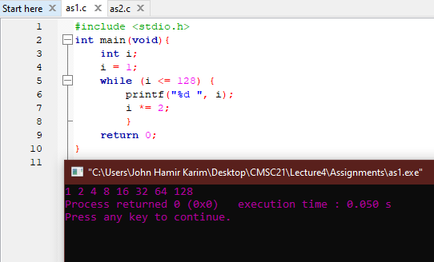

2. Which one of the following statements is not equivalent to the other two (assuming that the loop bodies are the same)?

- Although their outputs are the same, code ‘c’ always executes at least once, regardless of the value of ‘i’. On the other hand, ‘a’ and ‘b’, will check the ‘i’ value first before executing. If i > 10, a and b will not run at all, but c will run once.

3. Convert item 1 into an equivalent for statement. You can validate your answer by checking if the produced outputs by both the while and for statements are similar.

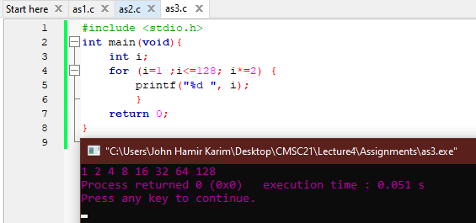

4. Write a code that computes for the power of two:

5. Write a program that displays a one-month calendar.

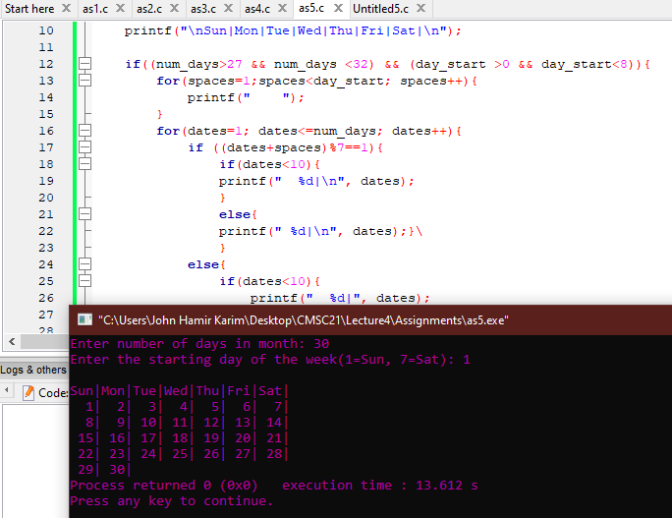

Github: https://github.com/HelloCigar/CMSC21/tree/main/Lecture4/Assignments